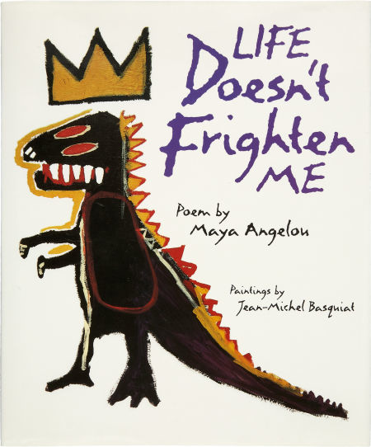
Student Teacher: Megan Altieri

Lesson Title: “Life Doesn’t Frighten Me”

Class: 2nd Grade

MI Department of Ed. GLCE:

ART.VA.II.2.2 Combine the use of elements of art and principles of design to communicate ideas.
ART.VA.II.2.3 Understand and recognize how artists create and construct multiple solutions to visual problems in artworks.
ART.VA.III.2.5 Reflect on how art expresses ideas, feelings, and opinions. ART.VA.II.2.5 Compare and contrast how artists convey ideas through
the creation of artwork.

- District Objective(s): I can create a painting like Jean-Michael Basquiat that expresses a story of my fears.

- Behavior Management Procedures: Students will gather in a close group around the book so they will be engaged. Expectations for their behavior will be clearly stated before the lesson about keeping hands to self and use of materials.

- Materials:

- “Life Doesn’t Frighten Me at All” by Maya Angelou
- Easel
- Painting paper
- Tempra paint
- Paint brushes
- Water
- Butter containers for water
- Newspaper
- Construction paper to mat work
- Text strips “Life doesn’t frighten me at all.”

- Resources, Books and Websites: “Life Doesn’t Frighten Me at All” by Maya Angelou and illustrated by Jean-Michael Basquiat

- Lead questions/Anticipatory Set:

- Read “Life Doesn’t Frighten Me’ out loud to the class
- Question for students: “What did you notice about the illustrations in this book?” (colorful, crazy lines, not realistic, sloppy)
- Discussion: Who is Basquiat and how did he paint? How his paintings connected with ideas in Angelou’s poem?
- My story: Told students a story about something that scared me when I was little. I showed different brush strokes to make different kind of lines and colors to show emotions. The observed me make mistakes and correct them not by starting over but by making them into something else or painting over it.

- Sequence of instruction: Demonstration, Guided Practice, Independent Practice. List the specific steps of the process and techniques for using the media, including problem solving strategies and aesthetic choices. Demonstration:

- As I told the story, I started painting the image on an easel in front of them. I expressed how I “envisioned” the scene and asked for their suggestions and ideas for how to portray that vision on the paper. What lines should I make for fire? What color should I paint the giraffe if it was evil?
- Showed different brush strokes to make different kind of lines and colors to show emotions
- Students observed me make mistakes and correct them not by starting over but by making them into something else or painting over it
- Narrate my thoughts as I paint showing them how thoughts turn into art and like Basquiat, not worry about making it look “real”
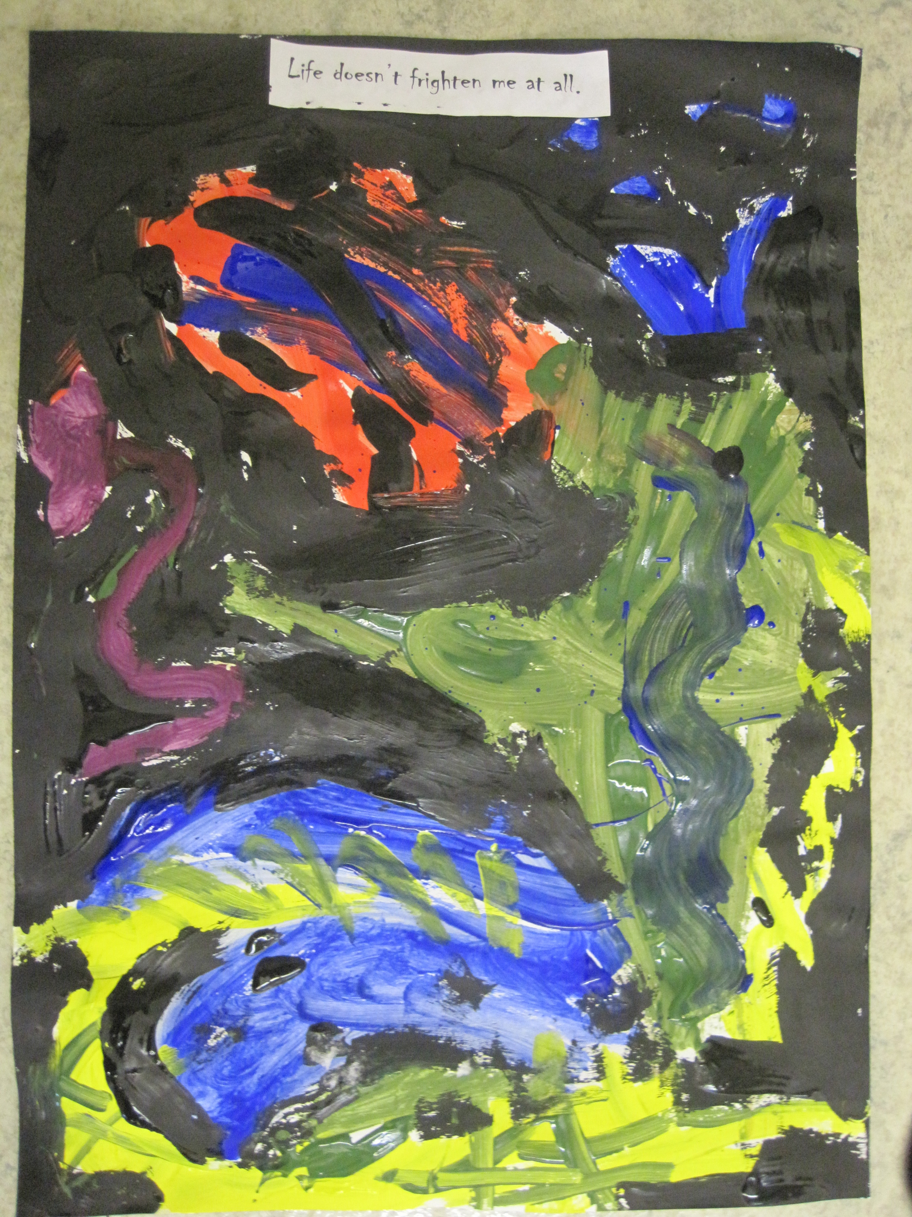
Independent Practice:

- Students spent 5-10 minutes brain storming and make sketches of their fears
- Students start their paintings with no preliminary sketch (like Basquiat)
- Students paint their stories independently considering the best lines and colors to express their messages

Steps:

- Students are dismissed from reading circle to their tables
- Students have pencils and paper to brainstorm by sketching or write about their fears
- One student from each table gets brushes for their table, one gets paint, one gets scrap paper, and one gets water containers
- Students are encouraged to experiment and explore with line and color before their start their pieces, different brushes make different lines
- Students raise hand when ready for final paper
- Student are given remaining time to work on their piece, approx 30 minutes
- Students who finish early are encouraged to add pattern, lines, or shapes that might strengthen the visual message in their story or they may start another piece
- Students set finished work side by side on drying table and clean their tables
- Students sit at their seats
- Closing: Facilitated discussion about how line and color expresses the message of the story

- Plans for Differentiation:
- ADHD: Student sits at private table to minimize distraction, teacher checks for understanding individually
- Gifted: Students are encouraged to not only think about color and line but elements of composition such as balance

- Evaluation/Assessment: Formative: Mid-way through student-work period ask students to point to the art elements of line and color in their work and have them explain to the class how they used them to tell their story Summative: Students graded on a written assessment that asks them how they used line and color to portray the message in their story.

