Coach Meg
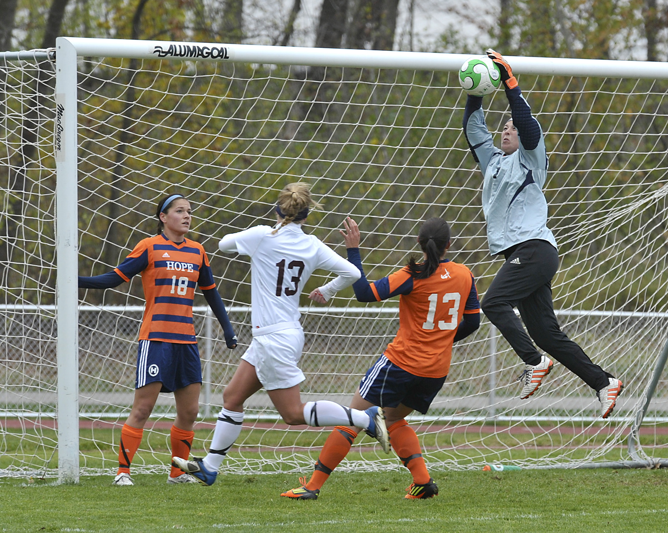

Coaching Philosophy
I view coaching as a responsibility to help student athletes excel socially, academically, and athletically. I desire to teach my players how to prioritize these aspects. I will have them set both individual and team goals at the beginning of the season. I will encourage them to seek victory, team intimacy, fun, and academic success. I will plan practices and team events that are motivated by the achievement of these goals. I will instill in the players the obligation and desire to work hard for their coach, their team, and themselves. There will be requirements that each member on the team respects on another. I will organize team-building activities that teach the team to cooperate and respect each other for the purpose of reaching a common goal. I will encourage my players to find identity and self-worth in their athletic ability but also understand that their education will take them the farthest. The only excuse for missing a practice is for academic purposes. My players will learn what it means to be in a commitment. They will practice promptness and reap the consequences otherwise. I will teach them virtues that will take them far in every aspect of their life. Through my actions, my players will be certain beyond a shadow of a doubt that I am dedicated to making them better athletes and better people. My team will succeed because they will work hard in practice, respect one another, and have fun.
Email: megan.altieri@hope.edu Phone: 440-503-716
Freshman
Girls Schedule

Season Start Date: 03/11/2013
Season End Date: 06/30/2013 (State Tournement)

Date | Event Type | Opponent | H/A | Time
04/10/2013 | Match | Grandville | Home | 5:00 PM
04/11/2013 | Match | West Ottawa | Away | 4:00 PM
04/15/2013 | Match | Wyoming | Away | 4:00 PM
04/23/2013 | Match | West Ottawa | Home | 4:00 PM
04/25/2013 | Match | Grandville | Home | 4:00 PM
04/26/2013 | Match | Wyoming | Home | 4:00 PM
04/30/2013 | Match | Rockford | Home | 4:00 PM
05/02/2013 | Match | Grand Haven | Away | 4:00 PM
05/03/2013 | Match | Holland Christian | Home | 5:00 PM
05/07/2013 | Match | East Kentwood | Away | 4:00 PM
05/09/2013 | Match | West Ottawa | Away | 4:00 PM
05/14/2013 | Match | Grandville | Away | 4:00 PM
05/16/2013 | Match | Rockford | Away | 4:00 PM
05/20/2013 | Match | Grand Haven | Home | 4:00 PM
05/22/2013 | Match | East Kentwood | Home | 4:00 PM

Pump-Up! Schedule
Quotes - Skits - Raps - Songs - Stories - Jokes - Dances - Speeches

DATE OPPONENT PUMP-UPERS

April 10 Grandville Daphne & Rhianon
April 11 West Ottawa Mackenzie & Lydia
April 15 Wyoming Gretchen & Kaylee
April 23 West Ottawa Madison & Nikki
April 25 Grandville Maddie & Brenna
April 26 Wyoming Jasmine & Leilani
April 30 Rockford Emily & Lydia
May 2 Grand Haven Daphne & Gretchen
May 3 Holland Christian Rhianon & Mackenzie
May 7 East Kentwood Kaylee & Brenna
May 9 West Ottawa Leilani & Madison
May 14 Grandville Nikki & Maddie
May 16 Rockford Emily & Jasmine
May 20 Grand Haven Daphne & Kaylee
May 22 East Kentwood Coach Meg

Who Are We?

- How would you want your opponents to view the team?

- How would you like to be perceived during practice; what would spectators of the practice say about you and the team?

- How would you want your team to be perceived by your school?

- How do you want to be treated by each other?

- How do you want to be treated by the coach?

- How do we want to treat each other when there is conflict?

Goal Sheet

- What are your strengths?

- What are your weaknesses?

- What are your personal goals for the season?

- What are your goals for the team?

Journal #1

Talk to me! Including but not limited to…
  - How are you doing?
  - What do you need to work on- on and off the field?
  - What can I do better?
  - What does the team need right now?

Dear Coach,

Journal #2

Talk to me! Including but not limited to…
  - How are you doing?
  - What do you need to work on- on and off the field?
  - What can I do better?
  - What does the team need right now?

Dear Coach,

Journal #3

Talk to me! Including but not limited to…
  - How are you doing?
  - What do you need to work on- on and off the field?
  - What can I do better?
  - What does the team need right now?

Dear Coach,

Personality Indicator
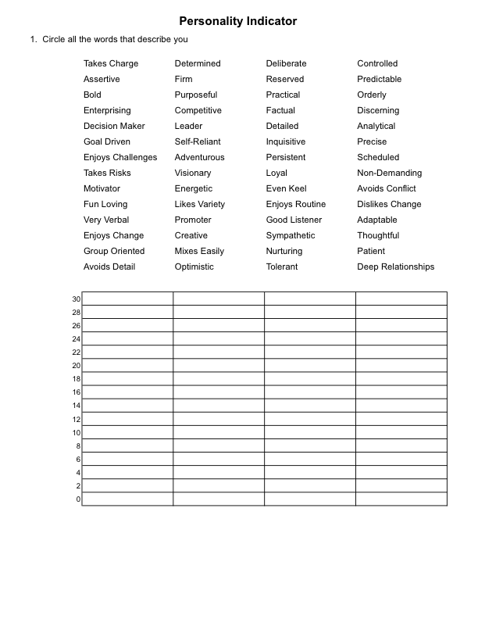

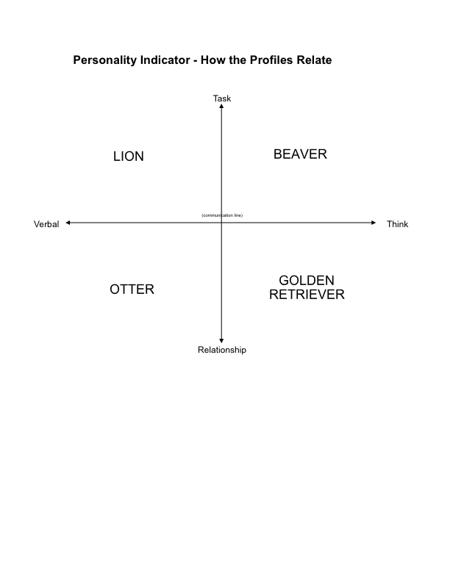
How Profiles Relate
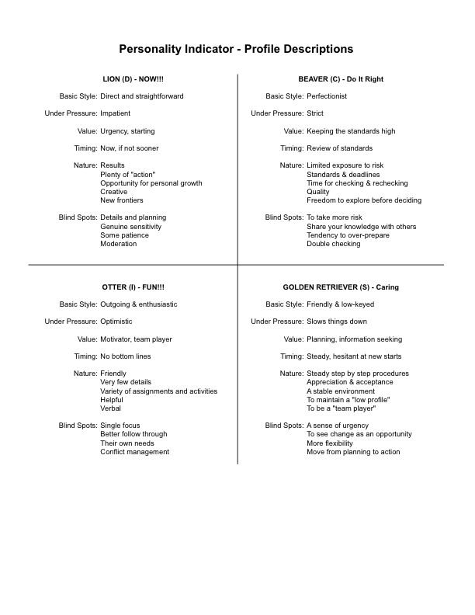
Team Goals

“Practice became a legitimate war.
It was a war you were permitted to fight in, to go after each other.
It was honorable to carve up your teammates. It was the only way to practice.
We ended up with a wonderful dichotomy—
when you cross the line of field, I’m going to cut you in half to get the ball .
Off the field, we take care of each other as a family.
If you are carrying three bags from the bus…
I’m going to grab two bags off your shoulders and carry them myself,
even though that welt in the back of my thigh
is your cleat mark.”

- Anson Dorrance

Coaching Philosophy
I view coaching as a responsibility to help student athletes excel socially, academically, and athletically. I desire to teach my players how to prioritize these aspects. I will have them set both individual and team goals at the beginning of the season. I will encourage them to seek victory, team intimacy, fun, and academic success. I will plan practices and team events that are motivated by the achievement of these goals. I will instill in the players the obligation and desire to work hard for their coach, their team, and themselves. There will be requirements that each member on the team respects on another. I will organize team-building activities that teach the team to cooperate and respect each other for the purpose of reaching a common goal. I will encourage my players to find identity and self-worth in their athletic ability but also understand that their education will take them the farthest. The only excuse for missing a practice is for academic purposes. My players will learn what it means to be in a commitment. They will practice promptness and reap the consequences otherwise. I will teach them virtues that will take them far in every aspect of their life. Through my actions, my players will be certain beyond a shadow of a doubt that I am dedicated to making them better athletes and better people. My team will succeed because they will work hard in practice, respect one another, and have fun.

Practice Practice will be held every day other than game days and Sundays at 4:00. Girls are expected to arrive at 3:45 and be warmed-up and stretched by 4:00. All practices are mandatory.

Expectations Athletes are expected to attend all practices and games. Valid excuses are sickness, family issues, and academic commitments. Athletes are expected to work hard at every practice.

Parents If student- initiated problem solving has not brought a remedy, a meeting should be mutually agreed to by all parents and coaches involved. Hudsonville Soccer practices a 24-hour rule. Clarity with an issue often comes by “sleeping on it” The following issues are considered appropriate issues to discuss with coaches: expectations during practice/games, strategies for the student athlete to improve, availability of academic support, and playing time.

When you see yourself doing something badly and nobody’s bothering to tell you anymore, that’s a bad place to be. You may not want to hear it, but your critics are often the ones telling you they still love you and care about you and want to make you better.
Randy Pausch

The greatest problem with the modern world is the inability to make a commitment. -T.S. Elliot

If a team is not bound by more than a simple desire to win, their striving will be losing. I’m not knocking the desire to win- that has to be there- but the over riding question is this: does your team love?

The greater the obstacle, the more glory in over coming it. -Moliere
There is no education like adversity.
-Benjamin Disraeli

I hated every minute of training, but I said “don’t quit”. Suffer now and live the rest of your life as a champion.” -Muhammad Ali

Success doesn’t come to you…you go to it.
-Marva Collins

Even if you’re on the right track, you’ll get run over if you just sit there.” -Will Rodgers

