Student Teacher: Megan Altieri

Lesson Title: Paper Mache Guitars

Class: Hamilton Middle School 7th grade

- MI Department of Ed. GLCE: ART. VA.III.7.2 Interpret artwork searching for embedded meaning, function, and personal connections at an emerging level. ART.VA.II.7.4 Initiate new ideas employing inventiveness and innovation at an emerging level with increasing independence

- District Objective(s) : I can create a paper mache guitar that expresses my own identity.

- Behavior Management Procedures: Students will share supplies with their table to minimize time gathering materials and crowding. Students will be given goals at the beginning of every class in order to stay focused on completing a set of tasks for that class period.

- Materials:
- Pencil
- Sketch paper
- Cardboard
- Box cutter
- Scissors
- Newspaper
- Plain newsprint
- Masking tape
- Wooden dowels/old colored pencils (optional: guitar neck support)
- Paper mache mix
- Water
- Bucket
- Tempra or acrylic paint
- Paint brushes
- Small dishes/empty butter container
- Mod Podge

- Lead questions/Anticipatory Set:

- Introduce lesson with powerpoint about the Guitar Mania exhibit at Cleveland Rock n Roll Hall of Fame. Second slide presents four guitars and students will be asked: - What can you tell about the artist’s identity by looking at their guitar?
- Show slide that introduces focus words: shape, form, color, texture, identity - How can you use the above concepts to express your identity in your guitar?

- Sequence of instruction: Demonstration, Guided Practice, Independent Practice. List the specific steps of the process and techniques for using the media, including problem solving strategies and aesthetic choices.
- Demonstration: Draw shape of guitar on cardboard, cut out with box cutter, trace that shape onto another cardboard to duplicate, tape balls and coils of newspaper to one cut out, then sandwich the newspaper between two cardboard sides, loosely tape sandwich together
- Guided Practice: After paper mache demo, students were guided in specific solutions for mache application when building upon wet layers of mache
- Independent Practice: After demos and guided practice, students complete cardboard construction, paper mache application, and painting/sculptural details independently
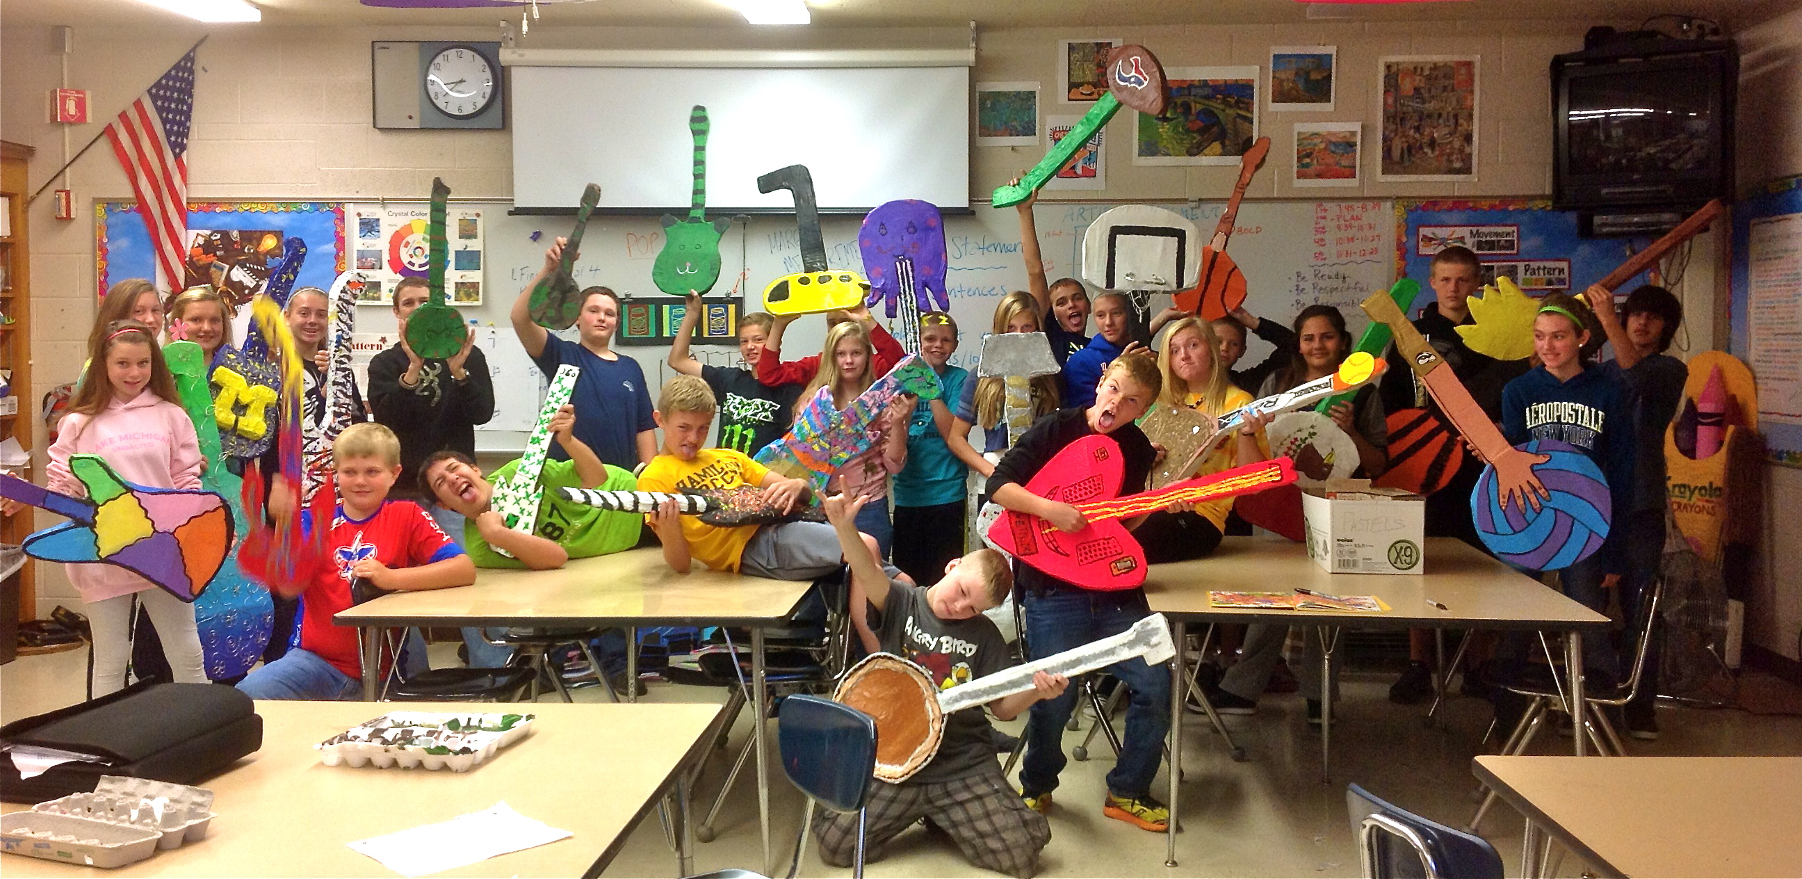
- Steps:

- Students make a list of character traits and interests
- Sketch a guitar that expresses their identity including color, texture, shape, and form
- Make a contour for the shape of guitar
- Trace guitar to make identical cut out shape
- Tape newspaper balls in the middle of the shape and coils on the edges of the shape
- Sandwich the second identical guitar on top of the taped newspaper and loosely tape the sandwiched cardboard pieces together
- Mix mache paste with water
- Begin paper mache application by ripping strips of newspaper vertically from the fold, dip in mache paste, then squidgy the mache off until there is a film over the strip
- First layer of mache: Strips should be applied in way that connects the two cardboard piece
- First layer covers the entire surface area
- Second layer: strips should be applied in opposite direction
- Third layer: White newsprint is applied for last layer so paint can be applied on a solid surface
- Paint or sculptural techniques are applied
- Prevent paint cracking by applying mod podge as a finish coat

- Plans for Differentiation: Gifted Students: I will push them to not only treat their guitars like canvas but also as a sculpture. I would encourage them to add sculpture elements to their piece to emphasize their form. ADHD Students: will be given the option to work in the hallway with fewer distractions. They will also be given a list of goals for the class period in order to keep them on track.
Anxiety/OCD Student: will be given a separate table to keep his supplies organized. He will be allowed to use headphones to drown out noise.

- Evaluation/Assessment: Formative: Students will be given a pre-assessment “smart sheet” that asks them to write their prior knowledge about the focus words: shape, form, texture, color, and identity.
Students participate in group critiques that discuss what impression their guitar gives about the person they are. Group will work on decoding themes, colors, and images and communicating how those elements show identity in their classmates work.
Summative: Students take post-assessment that asks them to explain their new understanding of their focus words then write a paragraph that synthesizes that knowledge in the context of their project. Students are also give the chance to use a standardized rubric to score their own project out of 100 points in the categories of following directions, originality, neatness, and participation. Then the project will be teacher assessed in the same categories and point value.

