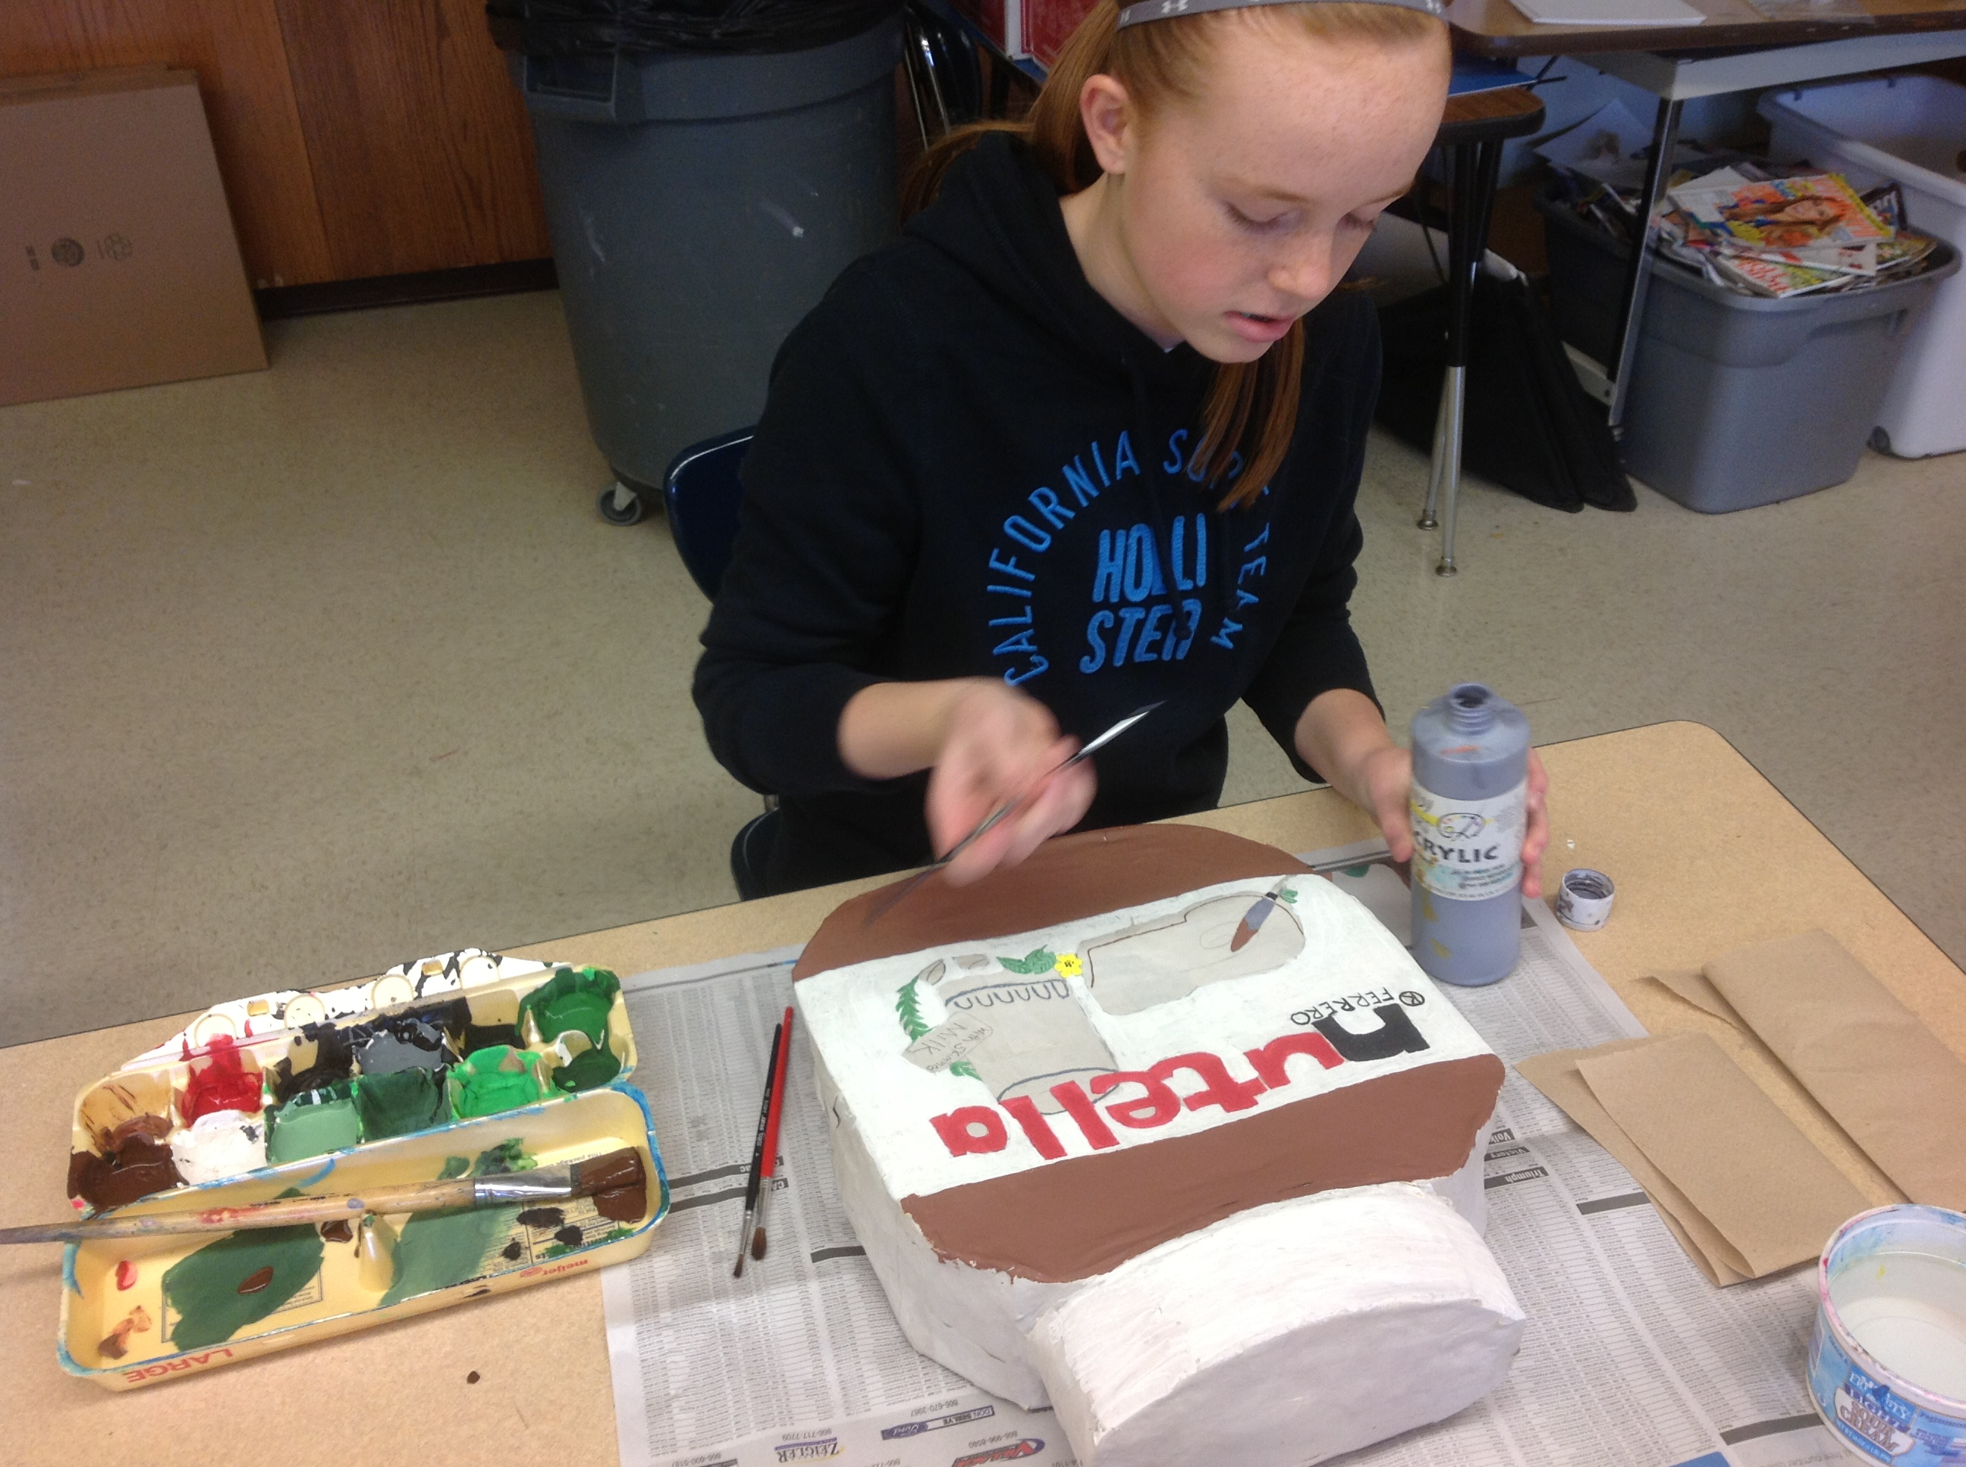
POP ART SERIES UNIT PLAN

8TH Grade // Drawing, Printmaking, & Sculpture

Overview

Theme: Pop Art
Big Ideas:
- Lead artists in pop art
- What is pop culture
- Techniques of still life contour drawing, printmaking, and creating forms
Unit Overview
- Students will examine a 3-D subject while drawing in a representational manner using the contour drawing to create a series of prints and recreating the drawing in the 3-D process of cardboard sculpting.
Rational
- After discussing pop art students will choose a pop culture icon to represent in three mediums. Students will develop higher order critical thinking by defining pop art style, selecting appropriate materials, and subject. To draw and recreate 3-D forms, students will need to examine line, shape, proportion, employing mathematical and spatial concepts. Students will continually evaluate relationships as they draft and refine in the process of creating drawings, prints, and sculptures.
Standards
- ART.VA.IV.8.1 Recognize, describe and analyze, and evaluate how art contributes to and reflects all societies and cultures.
- ART.VA.IV.8.2 Articulate an understanding of the historical, social, and cultural contexts of artwork with aesthetic sophistication.
- ART.VA.III.8.2 Effectively interpret artwork, searching for embedded meaning, function, and personal connections.
- ART.VA.I.8.2 Appropriately apply the concept of proper use of art materials and using tools safely and responsibly.
Objective: I can create a series of three pop art pieces using contour line drawing, printmaking, and paper mache sculpture.

Unit Lesson Plans

Introduction: Pop Art Powerpoint

- Objective: I understand the main ideas and artists surrounding pop art.
- Pop Art History Lesson: What is Pop Art? What is pop culture?
- Ideas and concepts pop arts based their work on
- Lichtenstein and Warhol
- Warhol’s objectives in his work
- Guided Practice: Interview with students to playing parts followed by discussion about connections to their lives
- Conclusion of main points
- Explain unit: Contour drawing to printmaking to sculpture showing examples
- Theme: Students choose a pop culture item subject to base their 3 projects off of
- Subject should be a pop culture item of their choice—anything mass produced, everyday objects, brand names, recognizable by everyone
- Ask students to give examples: “Oreos!” “Nike cleat!”

Guided & Independent Practice

Lesson 1: Contour Line Drawing

- Objective: I can create a contour line drawing from examining a still life object.
- What is contour drawing? What is still life drawing?
- Demo: drawing water bottle through talk and draw
- Explain thought process of measuring, comparisons, checking angles, and checking for accuracy
- Show difference between rendering and contour drawing
- Independent Practice: Pass out objects for still life and students begin their drawings

Lesson 2: Printmaking

- Objective: I can use my contour drawing to create a linoleum pop art print.
- What is print making?
- Demo Transfer & Carving: Trace and transfer drawing to linoleum with ebony pencil
- Inversion corrects itself when linoleum is printed on paper
- Scoop away linoleum, following lines, pushing away from body and support hand behind the tool
- Start lightly and increase pressure for deeper grooves
- Show knife blade sizes and explain which to use for which areas
- Explain that carved areas is negative space and untouched areas will be inked
- Demo printmaking: emphasizing centering, neatness, and margins
- Explain strategies of rolling ink
- Show what happens with too much ink, too little ink, too much pressure, and too little pressure
- Demo dry mounting: Measuring margins, centering prints, and rubber cement application
- Explain signing: Left to Right: Print copy number ratio (1/4), Title in quotes, signature
- Explain the steps and where they go for each station
- Independent Practice: Students begin process of transferring drawings, making prints, and mounting

Lesson 3: Sculpture

- Objective: I can create a form cardboard paper mache sculpture
- Structure Demo: Sculpture building techniques starting with a general sketch or jot down measurements
- Discuss proportions and show examples of disproportion
- Show cardboard frame building, then newspaper stuffing process
- Explain how to crumple paper so it supports the cardboard but is not too dense
- Paper mache demo: Show how to rip paper into strips, cover in mache, then squidgy mache with bunny ear fingers
- Explain how to lay strips strategically so that they hold together structure, lay strips over seams and corners
- Students will cover two layers of news paper and the final third layer in white newsprint then piece will dry
- Painting Demo: Apply acrylic paint first using the background color of the object (green for Gatorade water bottle)
- No white space, brush strokes like mowing the lawn, multiple coats
- Detail work is done after background is dry using smaller brushes and light pencil sketches
- Mixing color to get correct hue—reference the color wheel for tips, demo examples of how to get lime green
- Independent Practice: Students begin sculpture process of sketching proportions building, maching, and painting
Materials
- Still life/pop culture item
- Newsprint
- Ebony Pencil
- Linoleum
- Linoleum carving tools
- Ink
- Brayer
- 5 x 7 colored paper
- 16 x 20 black/white mounting paper
- Ruler
- Rubber cement
- Cardboard
- Newspaper for stuffing and table covering
- Box cutter
- Masking tape
- Paper mache powder / water
- Buckets for mache
- Acrylic paint
- Metal rod
- Wood pedestal
- Typed plaque

Assessment
Formative:
- Checking for Understanding: On days that require a lot of steps students are called on to repeat their directions and the reasons for those directions
- Group Critique: Students check each others angles for their still life drawing
- Thumb-mometor: Thumbs up, down, or sideways depending on their understanding of concepts, techniques, or instructions.
- Museum
- Exit Tickets: As students go from shape to form in creating their sculptures, they should show through words, numbers, or pictures how they’re going to figure out the measurements of their form.
- Q & A: Students ask who class questions about their project (How can I make a bumpy texture on this piece?) Call on students for ideas.
Summative:
- Smart Sheet: Before the unit, the students are given a smart sheet that asks for their knowledge of the unit objective terms (pop art, pop culture, Andy Warhol, contour line drawing, printmaking, and form). After their finished with the unit, students take a post-assessment that asks them to show their knowledge of those same vocabulary words. Along with this, students write a paragraph that synthesizes their knowledge of these words and puts them in context of their projects.
- Rubric: Three rubrics will be given, one for each medium in the series. Students will be graded on participation, following directions, effort, and creativity. Students will be scored out of 100 and will have the opportunity to score themselves before teacher scores them.

Interdisciplinary and Literacy Connections

- Social studies: Students will have a teacher-facilitated discussion about how the culture of post WWII American society essentially created the pop art movement. They will recognize this relationship and come up with their own pop art icons of present day society to create.
- Math: Students will be required to sculpt their object three times bigger than the actual object. They will have to consider proportions as they change the scale. They will also be required to use measuring and dividing skills to
- Literacy: In the post-assessment, students are asked to synthesize their knowledge on the vocabulary words we focused on and contextualize these words in terms of their series.

Meeting Diverse Needs

- Accommodations: For ADHD students I will leave the steps for the project written up on the board so they can measure their progress. I will check in with them more frequently in order to keep them on track. Advanced students will be challenged to take their sculpture to the next level by really altering the shape of the cardboard box to make their desired form. They will be pushed to problem-solve.

- Multiple Intelligences
- Visual-Spatial: Students will need to use visual-spatial skills as they draw their object, taking it from form to shape, then back to form when they sculpt it. They will need to understand 2-D to 3-D (and vice versa) transitions.
- Logical/Mathematical: Students will engage in logical/mathematical intelligence during the sculpture portion of their unit because they will have to increase the scale by three times while maintaining proportion and considering depth along side of height and width. They use measuring when they are creating margins when they mount their four prints together. They will also be involved in creating the paper mache, which takes measuring.
- Kinesthetic: Making paper mache also allows for kinesthetic intelligence by having to pour and mix material. Also, the carving, printmaking, and paper mache sections both require a wide range of movement to move through the steps of printing and move around the sculpture to create it.

3) Bloom’s Taxonomy
- Cognitive: Students are using cognitive skills when analyzing and synthesizing information from the Pop Art History lesson and using it to brainstorm ideas for their subject. They also use it measuring margins in printmaking, proportions in making mache, and multiplying scale in sculpture.
- Affective: Students choose an object that they see as being a formative icon of their pop culture. In this, their assessment of culture is validated and they get to have say over what is “mass produced”. They are given choice in subject as well as color in printmaking. Gaining creation skills in general will increase their confidence and aptitude as an artist.
- Psychomotor: Students are carving into their linoleum and moving through the process of using ink and making a print. In the sculpture, they will be moving around their piece building the structure and applying paper mache. They will have to use box cutters to cut cardboard and rip paper for the mache.

Behavior Management
- Expectations for safety with box cutters will be clearly stated. In order to use box cutters, they will have to sign them out with their name and the number on the cutter they took. Students will be given loose daily goals so they stay focused on moving forward with their series.

Pop Art Unit- Daily Plans

Thursday 09/26

Objectives
- I can create a series of three pop art pieces using contour line drawing, printmaking, and paper mache sculpture.

GLCE(s)
- ART.VA.II.8.6 Make knowledgeable choices about materials, techniques, media technology, organizational principles, and processes to effectively articulate ideas and communicate intended meaning.
- ART.VA.I.8.2 Appropriately apply the concept of proper use of art materials and using tools safely and responsibly.
- ART.VA.I.8.4 Effectively use reflective thinking skills to observe, analyze, and critically evaluate works of art for the purpose of improving technical quality.
- ART.VA.II.8.5 Consistently demonstrate reflective thinking practices when identifying, designing, and solving creative problems.
Steps
- Introduce Pop Art with Power Point presentation include the topics of the pop art movement, Roy Lichtenstein, Andy Warhol, consumerism, mass production, and the post WWII American culture

Assessment
- Before the unit introduction: Students are given a pre-assessment smART sheet of their prior knowledge of pop art and the mediums of contour line drawing, printmaking, and sculpture
- Checking for Understanding: What do you know about pop art? What do you think of when you hear the name Andy Warhol?

Friday 09/27
Steps
- Continue presentation focusing on Warhol’s paintings and prints
- Do VTS with students on Warhol’s Brillo installation
- Discuss take home points and concepts of

Assessment
- Checking for understanding: If Warhol was alive and making work in this day and age, what would he be making work of? (oreos, ray bans)
- Students are assigned to bring a pop art object to draw from

Monday 09/30
Steps
- Contour line still life drawing demo—going from form to shape
- Students start still life drawing

Tuesday 10/01
Steps
- Carving linoleum demo—ebony trace/transfer and explanation of negative and positive space
- Student continue working on still life drawings
- Some students move on to ebony pencil transfers onto linoleum/ carving

Assessment
- Students are to stand at a distance from their drawing to check angles

Wednesday 10/02
Steps
- Demo ebony transfer and linoleum carving techniques and safety
- Transfer drawing with ebony to linoleum
- Choose variety of sized carving tools to get different line quality

Thursday 10/03
Steps
- Demo practice print and how to make alterations after assessing practice print
- Demo brayer rolling, paint application, centering, and removing paper from linoleum
- Students choose four colors of paper and four colors of ink
- Students begin practice prints and move onto final prints

Assessment
- Students should assess their four final prints on neatness and centeredness with their peers before they move on to mounting.

Friday 10/04
Steps
- Finish 4 final prints
- Demo dry mounting and 2” margins for boarder and 1” margins separating the 4 prints from each other
- Put examples and measurements on board as reference

Monday 10/07
Steps
- Explain printing making signing (print number, title, signature)
- Demo on card board sculpture techniques—cutting, shaping, sandwiching, stuffing, taping
- Paper mache demo—ripping newspaper, dipping, applying and placing strategically
- Have ready examples for each stage of the process

Assessment
- Checking for understanding. Call on students to name and explain each step of the sculpture project

Tuesday 10/08
Steps
- Students pick out cardboard for size approx. 2-3 times bigger than their actual object but small enough to be held by rod and pedestal assuming it a hand held item
- Sketch out contour on cardboard
- Cut out with box cutter trace cut out shape onto another piece of card board and cut out so there are two of the same shapes

Wednesday 10/09
Steps
- Students make balls and coils of newspaper depending on thickness to sandwich between the two pieces of cardboard.
- Use masking tape to secure sandwich and newspaper in place.
- Tape around empty space (sides) to create a surface on which to place paper mache

Assessment
- Is your piece small enough to be suspended on a rod and pedestal? “Scale can sometimes get away from you when you’re in the moment of creating and focusing on detail”

Thursday 10/10
Steps
- Start paper mache
- Go over clean up procedures and do one reminder demo of application of mache
- 3 layers, final layer is plain newsprint

Friday 10/11
Steps
- Students continue to cover their pieces with paper mache
- See that all finished and mounted prints are turned in with rubrics

Assessment
- Checking for Understanding: Problem-solve construction of internal structures of different shapes. Hold up students work and talk about how to achieve their desired form with strategies we’ve talked about

Monday 10 /14
Steps
- Talk about make a form that allows for detail, discuss textures or implied textures that can be added to sculpture
- Continue working on structure of sculpture

Tuesday 10/15
Steps
- Continue construction of their structures
- Discuss and demo how to paper mache around contours and tight corners

Assessment
- Have students who have used problem solving techniques raise their hand and explain what and how they did it

Wednesday 10/16
Steps
- Transition from building structure to maching surface
- Explain how to add organic shapes to sculpture with newspaper and tape to give their sculpture a more shapely form

Assessment
- Hold up a student’s work who has yet to build up that surface—explain how they would start to do so
- Hold up a student’s work who has built up surface and explain how they did that

Thursday 10/17
Steps
- Students should be on the second or third layer of paper mache
- For students who are done with third and last layer of mache, explain how student will paint a main, base color then sketch font on the painted form
- If paint cracks, apply mod podge between coats of paint

Friday 10/18

Steps
- All students should be finished with building cardboard internal structure, all should be paper macheing

Monday 10/20

Steps
- All students should be finishing their last layer of paper mache by the end of class
- Students who are ahead should get their base layer of paint down and start sketching font, print, logos, and lines
Assessment
- Students break into tables and do a critique with their paper mached forms
- What can be improved on your form? How might you achieve that with the cardboard/mache techniques we’ve learned?
Tuesday 10/21

Steps
- All students should complete their first layer of paint and should sketch their detail work on top then mod podge to prevent cracking tempra paint over night
Wednesday 10/22

Steps
- Demo paint mixing for colors that students propose
- Discuss color wheel
Assessment
- Show a tertiary color and call on students to explain what colors would be used to reach that hue

Thursday 10/23

Steps
- Demo painting contours and shapes on sculpture
- General shapes of color should be painted before dark contour outlines so that that the outlines can be neat and bold
- Students continue painting sculptures
Wednesday 10/24

Steps

- Students continue painting sculptures
Thursday 10/25

Steps
- Demo drilling holes for rod and explain why I placed the holes where I did
- Depending on the scale and shape of the sculpture, students should start thinking about where and how many holes will be drilled in order to hold up their sculpture on a rod and pedestal
- Students continue painting
Assessment
- Hold up different piece and ask class where the holes should be drilled and how balance will be affected
Friday 10/26

Steps
- Students continue painting
- Finished students start drilling holes if approved of placement
- Holes are drill bit size of rod diameter
Monday 10/29-Wednesday 10/31

Steps
- Students finish painting
- Final coat of mod podge to prevent cracking
- Drill hole in sculpture
- Students drill another hole in wood block
- Paint wood block pedestal black or white
- One side of rod secured in wood block and the other secured in the sculpture to suspend it

Assessment: Effect of Teaching on Learning
- Pre-Assessment: Before the unit, the students were given a smart sheet that asks for their knowledge of the unit objective terms (pop art, pop culture, Andy Warhol, contour line drawing, printmaking, and form). The average score was 1.125/6 which yields 19% accuracy. Looking at the students answers, I saw that most of them answered “I don’t know” or a generic interpretation of the word.

- Post-Assessment: After the unit, we passed back this same sheet. On the back, the questions were listed again along with a space to write a small paragraph synthesizing their knowledge on the same vocab words as the pre-assessment. The average score was 5.7/6 yielding 95% accuracy. Their answers were thorough and related the vocabulary to the unit. Their paragraphs were a great indication of their knowledge as they were able to contextualize them in term so of their projects.

- Analysis of Assessment: It was clear that students learned new terms as well as elaborate on their prior knowledge of the terms. Their paragraph in the post-assessment was an indication that this unit was successful in helping the students understand the definition as well as application of the words on the assessment.

- The following is data collected pre-unit and post-unit:
Student # PRE POST
1 0/6 6/6
2 2/6 6/6
3 1/6 6/6
4 0/6 5/6
5 1/6 6/6
6 3/6 6/6
7 0/6 4/6
8 1/6 6/6
9 2/6 6/6
10 1/6 6/6
11 2/6 6/6
12 4/6 6/6
13 0/6 5/6
14 0/6 5/6
15 1/6 6/6
16 2/6 6/6
17 1/6 6/6
18 0/6 5/6
19 1/6 6/6
20 3/6 6/6
21 1/6 6/6
22 0/6 6/6
23 0/6 5/6
24 1/6 6/6
Accuracy %: Pre 27/144= 18% Post 137/144=95% Improvement %: 78%
Average Score: Pre 1.125/6 Post 5.7/6 Improvement Score: 4.58/6

Reflection
This lesson was really exciting and met so many objectives in terms of art techniques, materials, and history. I would definitely teach it again and suggest that other teachers consider this unit as well. If I were to teach this again, I would repeat the introduction and history lesson on pop art and post-WWII culture. This background knowledge connected their art to things they already knew and were interested in like media. The students had the same response to the artwork as the general publics response to pop art in the 1950’s. When I made them aware of that connection and validated their opinions about the work they felt like the understood the concepts of pop art. In our discussion, the students were excited about relating 1950’s pop culture to their pop culture. They brainstormed as a class about what Andy Warhol may have made art about if he was living now. Coming up with their own ideas helped solidify their knowledge.
In terms of the creation process, I felt like the contour line drawing was a perfect balance to the other mediums in the unit. This is especially a good starting point for classes who need structure and need to see measurable success. Many of the students who struggle with behavior did best in this lesson. It was a perfect balance to the less technical, more intuitive sculpture element. The order of lessons made sense in the product development as they moved from 2-dimensions to 3-dimensions. This also worked out in terms of transitioning from short-term to long-term lessons. The students felt excited and rewarded moving onto the next lesson because they increased in complication, responsibility, and uniqueness.
Regardless of the length of time it took to complete, I would not exclude any element from this unit. As a whole it met so many objectives and curriculum goals, as it included art history, US history, still life drawing, printmaking, sculpture, and plenty of math skills in measurements and proportions. Because they got to pick their subject—a favorite name brand or piece of candy—they were invested in each of the lessons results. They were also using drastically different skills from lesson to lesson. These facts made the unit continually interesting and motivating for the students.
Overall, I felt this unit went smoothly and I would not change any of the learning targets or daily objectives but I would reconsider some of my implementation of strategies. If I were to teach this lesson again I would have split the introduction of pop art up into two separate days. For the anticipatory set I created a pop art history presentation and discussion. The eighth graders were very excited and engaged initially but as the lesson went on it grew to be too academic to hold their interest. Even when they were engaged in discussion they seemed to just went to jump into the creation of their pieces. I feel that an appropriate response to their restlessness would be letting them know that this was an important element of the lesson to have in order to make the unit more exciting, comprehensible, and relevant to their core curriculum but also, consider their grade level and maybe give spread the information out into more mini lessons to make it more tolerable for them.
In terms of material management, I would change how I laid out the room for material management. I was so focused on the content and meeting learning targets that I did not strategies classroom management as closely as I should have which effect the final product. During instructional time, I emphasized the importance of neatness of their prints but I did not give them the best environment to meet the expectations of neatness. The students were too crowded at the ink tables. Also, there were too many students making prints at the same time so they were going through paper at a expectedly fast rate. If I were to do this again, I would spread the print making materials out over more than two tables and I would have half the class print one day and the next half print the next day.
Lastly, the sculpture portion of the lesson could have been improved by having a mini lesson about proportions when increasing sizes. We talked about it roughly but having multiple examples and a demo of how to do the math behind increasing the size of their sculpture by two or three times would have been helpful. Many kids ended up making their sculpture four to fives times bigger and often too tall.
At the end of this unit, I was extremely satisfied with student growth and impressed by their products, especially their sculptures. The progression from the contour line drawing lesson to the sculpture lesson was successful in that it went from teaching them technical measurable skills to more complex skills with more room for innovation. Overall, I feel this unit could be repeated with only minor instructional changes. It was well worth the time because of all the mediums, skills, and core curriculum that it covered.

